Chili
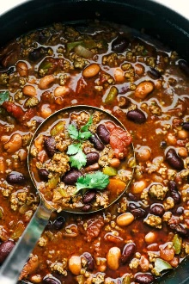
Prep time 20 min Cook Time 30 min
8 Servings
Ingredients
1 Tbsp olive oil
1 small onion, diced
1 green bell pepper, diced
2 garlic cloves, minced
2 lbs lean ground beef
2 cups beef broth
8 ounce can tomato sauce
15 ounce can diced tomatoes, undrained
15 ounce can pinto beans (optional)
15 ounce can kidney beans (optional)
3 Tbsp chili powder
1 Tbsp spoon oregano
1 tsp cumin
1 tsp coriander
1 tsp salt
¼ tsp cayenne
Directions
- Heat the olive oil in a large skillet over medium high heat. Add the ground beef and cook for 5 to 6 minutes, breaking up the meat with a spatula.
- Add the onion, bell pepper and garlic. Sauté until almost tender for an additional 3 to 4 minutes or until onion is translucent.
- Add the remaining ingredients: beef broth, tomato sauce, diced tomatoes, beans if used and spices.
- Bring to a boil and reduce to a simmer until it starts to thicken and flavors combine, about 30 minutes.

